Software Engineering 2017

# Group ID: A15

## *< Split Money Not Friends >*

|  |
| --- |
| C:\Users\BumbleBEE\AppData\Local\Microsoft\Windows\INetCache\Content.Word\IMG_20170913_200736.jpg |

|  |  |  |
| --- | --- | --- |
| Roll Number | Name | Role (PO+DEV/SM+DEV/DEV) |
| 15ucs037 | Devendra Samatia | PO + DEV |
| 15ucs032 | Ayush Tibra | DEV |
| 15ucs099 | Pranshu Sharma | SM + DEV |
| 15ucs055 | Vinay Jain | DEV |
| 15ucs049 | Harshit Jindal | DEV |

*+ order the names as per the order in the team selfie (left to right)*

**Section 1**

|  |
| --- |
| **Project overview**   1. It aids customers and their group members to reckon the group expenses in a hassle-free, automated and the reciprocally accepted way through the means of Chat Room, E -wallet, Push Notifications and Reminders. 2. it determines the fewest number of payments needed to reconcile the debt 3. helps the management with reports and functionality to improve effectiveness of various decision-making activities. |

|  |
| --- |
| **System purpose**  It efficiently keeps the track of money expenses among group members and also calculate who owes what to whom. |

**Section 2**

**(Clt + Click for direct redirection)**

[**URI for System Demo**](https://splitmoneynotfriends-assassinative-chitarrone.eu-de.mybluemix.net/users/login)

**🡺** **https://splitmoneynotfriends-assassinative-chitarrone.eu-de.mybluemix.net/users/login**

[**URI for UI/UX wireframes**](https://www.lucidchart.com/invitations/accept/6253eb45-e3ef-41d6-a904-7913911e7975) **(shared Lucidchart document folder) 🡺https://www.lucidchart.com/invitations/accept/6253eb45-e3ef-41d6-a904-7913911e7975**

[**Burndown chart**](https://docs.google.com/a/lnmiit.ac.in/spreadsheets/d/1hiesMtuA1X67PcJNJReznB1_6jh0_Uy7MhwdEy7nNX8/edit?usp=sharing) **🡺https://docs.google.com/a/lnmiit.ac.in/spreadsheets/d/1hiesMtuA1X67PcJNJReznB1\_6jh0\_Uy7MhwdEy7nNX8/edit?usp=sharing**

[**Scrum project management report**](https://docs.google.com/a/lnmiit.ac.in/document/d/1fA6njZMC7jmsj5s6ChIrvY2h9yz2k_zKrYHGjKq--jU/edit?usp=sharing)

**🡺https://docs.google.com/a/lnmiit.ac.in/document/d/1fA6njZMC7jmsj5s6ChIrvY2h9yz2k\_zKrYHGjKq--jU/edit?usp=sharing**

**Section 3**

**Work System Snapshot**

|  |  |  |  |  |
| --- | --- | --- | --- | --- |
| Customers | | | Product/Services | |
| * Customer   (group member) | | | * Push Notification * Bill Evaluator * Chat Room | |
| Major Activities and Processes | | | | |
| .   * The customer creates a new group and adds members into it. * Customer adds bill details describing the amount and proportion of the amount of each friend in the bill. * Customer sends the notification regarding the new bill to the respective participating group member.      * Group members will validate the bill amount and their participation in it. * Customer will chat about debts and other bill details with the group members to resolve issues.      * Manager inquires all final bills and then settle them by splitting it accordingly. * Customer requests admin to generate final transaction statement as a record.      * Admin notifies all the members of the same group about their debts and lending. * Manager settles payment of each customer according to their final settlement. | | | | |
| Participants | | Information | | Technologies |
| * Customer * Manager * Admin | * Transaction details * Feedback form * User Details | | * Email * Spreadsheet * Computer * Internet * Scanner |

**Section 4**

**Use case diagram with nested boundary**

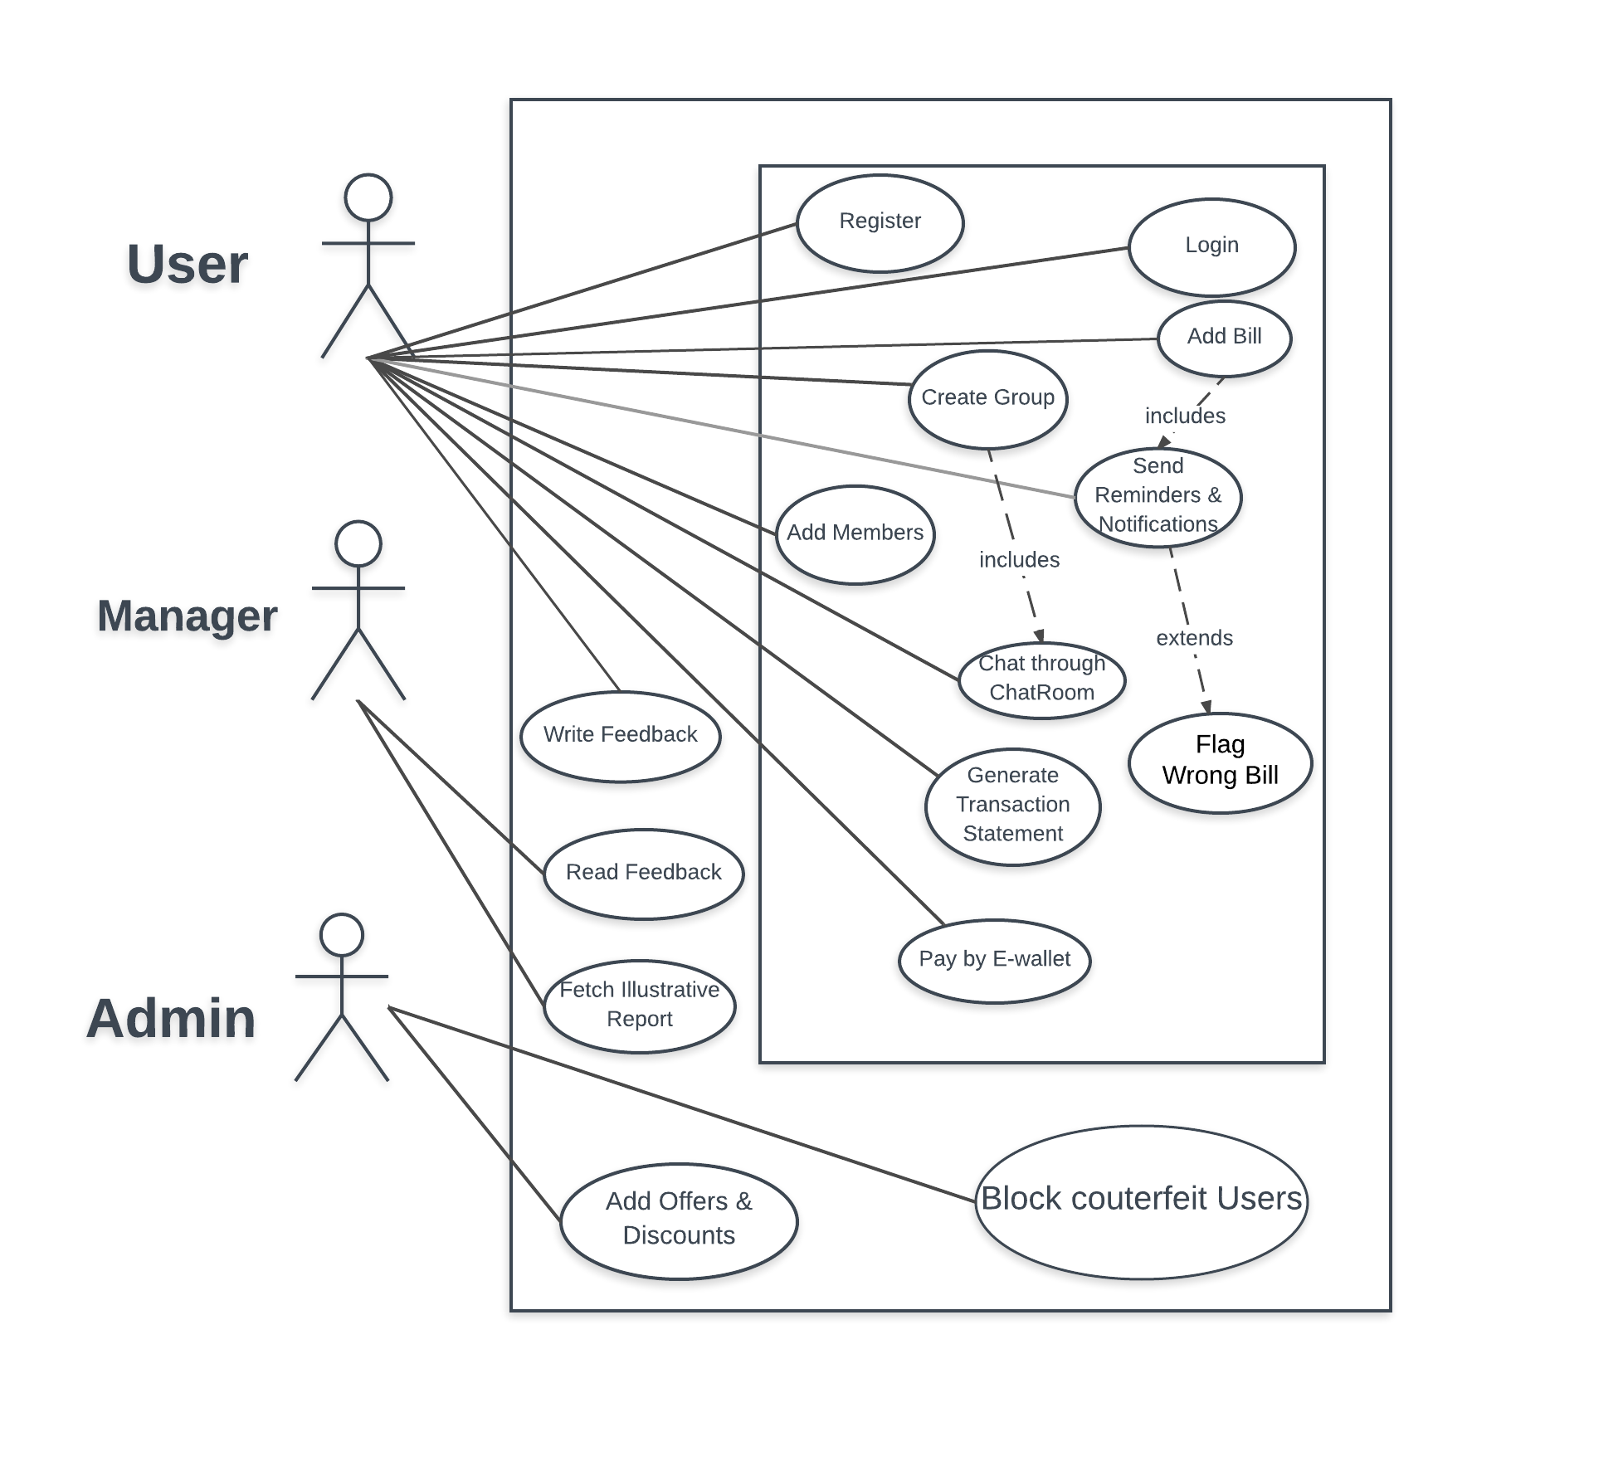

**Section 5**

**Product Backlog (format sprint 2 rows in bold)**

|  |  |  |  |  |
| --- | --- | --- | --- | --- |
| Story ID | As a/an | I want to … | so that … | Priority (H/M/L) |
| 1 | Customer | I want to register and access my account | I can split bills with my friends. | H |
| **2** | **Customer** | **Add contacts to my accounts** | **I can add members and keep records** | **H** |
| 3 | Customer | Create a group and add members | We have a place to chat and add bills. | H |
| **4** | **Customer** | **Get final transaction statement for a group** | **I can settle my debts in real world.** | **H** |
| **5** | **Customer** | **Add a bill in a group** | **I can tell group members of a expense.** | **H** |
| 6 | Customer | Write feedback | I could have lent manager know the changes I want. | L |
| **7** | **Customer** | **Get notification for every transaction** | **I can flag a wrong bill.** | **M** |
| **8** | **Customer** | **Chat with my friends and group members** | **We can discuss about transactions** | **M** |
| **9** | **Customer** | **Pay money through wallet.** | **Settle debts with friends** | **M** |
| 10 | Manager | Get analysis on amounts of transactions and types of expenses. | I can decide what kind of offers to give. | M |
| 11 | Manager | Read feedback from customers | I can know what changes customers want. | L |
| 12 | Admin | Add features and discount offers as per manager report. | User experience can be upgraded. | M |
| 13 | Admin | Block user and delete accounts. | I can protect website from cyber-attacks. | M |

**Sprint 2 Plan (Backlog)**

|  |  |  |  |  |  |
| --- | --- | --- | --- | --- | --- |
| Story ID | As a/an | I want to … | so that … | estimate | actual |
| 2 | **Customer** | **Add contacts to my accounts** | **I can add members and keep records** | 6 | 8 |
| 4 | **Customer** | **Get final transaction statement for a group** | **I can settle my debts in real world.** | 8 | 8 |
| 5 | **Customer** | **Add a bill in a group** | **I can tell group members of my expense.** | 10 | 11 |
| 7 | **Customer** | **Get notification for every transaction** | **I can flag a wrong bill.** | 10 | 12 |
| 8 | **Customer** | **Chat with my friends and group members** | **We can discuss about transactions** | 18 | 20 |
| 9 | **Customer** | **Pay money through wallet.** | **Settle debts with friends** | 22 | 24 |

**Section 6**

**Acceptance criteria and test result**

(note: a story ID may have multiple rows; one for each acceptance criteria to be tested)

|  |  |  |
| --- | --- | --- |
| Story ID | Acceptance criteria | Test Result |
| 1 | When a user register/login with one or more empty fields then It displays “Please fill out this field” i.e. all fields are required | Passed |
| 1 | When some user registers/logins an invalid email (not with @ and .com etc.) it displays “Please enter valid email address “ | Passed |
| 1 | User is not allowed to register using first name or last name with more than 30 characters | Passed |
| 1 | Users ‘Phone no. is required to be of length 10 to 12 numerical digits for registration | Passed |
| 1 | If a user enters with an unregistered email id then it displays “Unknown User” | Passed |
| 1 | If a user enters with a wrong password with email id then it displays “Wrong password” | Passed |
| 1 | If a user logs out the it displays “You have successfully logged out” and redirects to login page | Passed |
| 2 | Group name is mandatory and minimum one member is required | Passed |

**Section 7**

**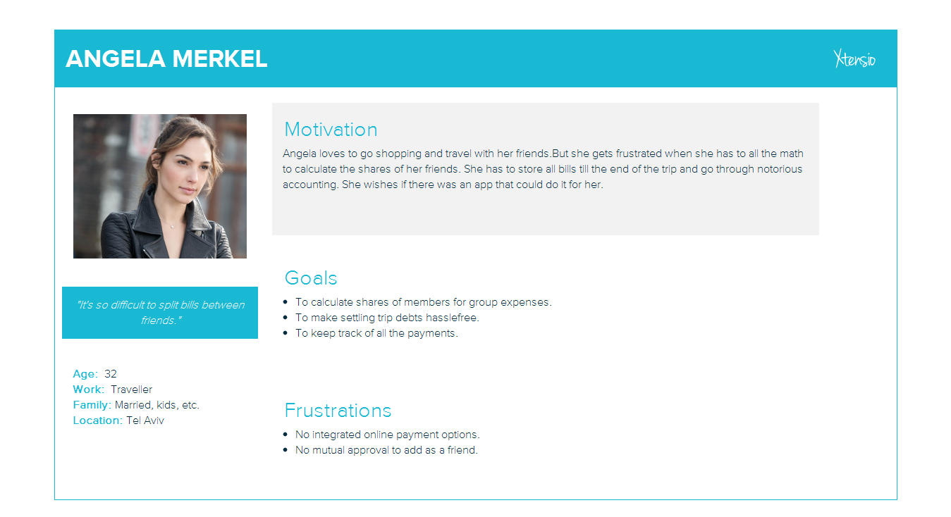**

**Personas**

**Section 8**

**Activity diagram – Top level**

<*linking all the use cases in the use case diagram*>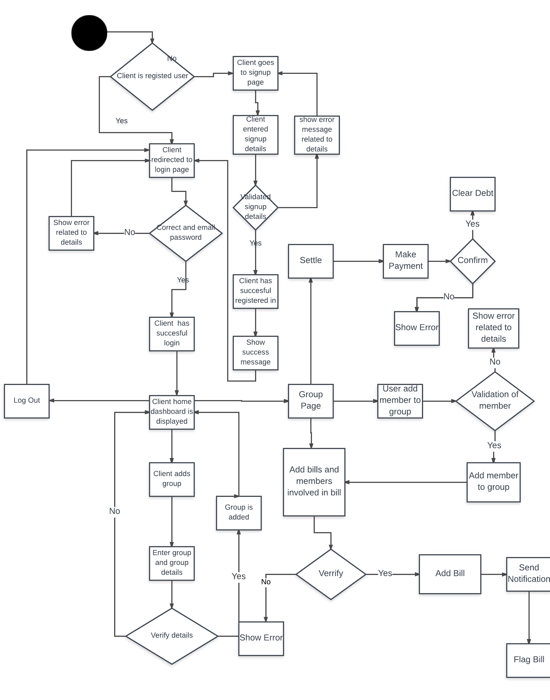

**Activity diagrams**

<*Approximately one for each team member with correct notation; diagrams should include business activities/operations – not UI navigation and concepts*>

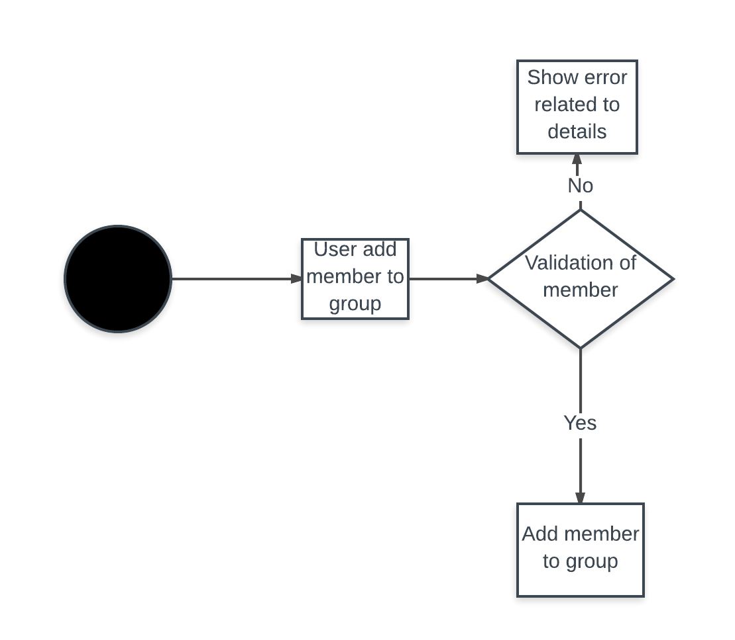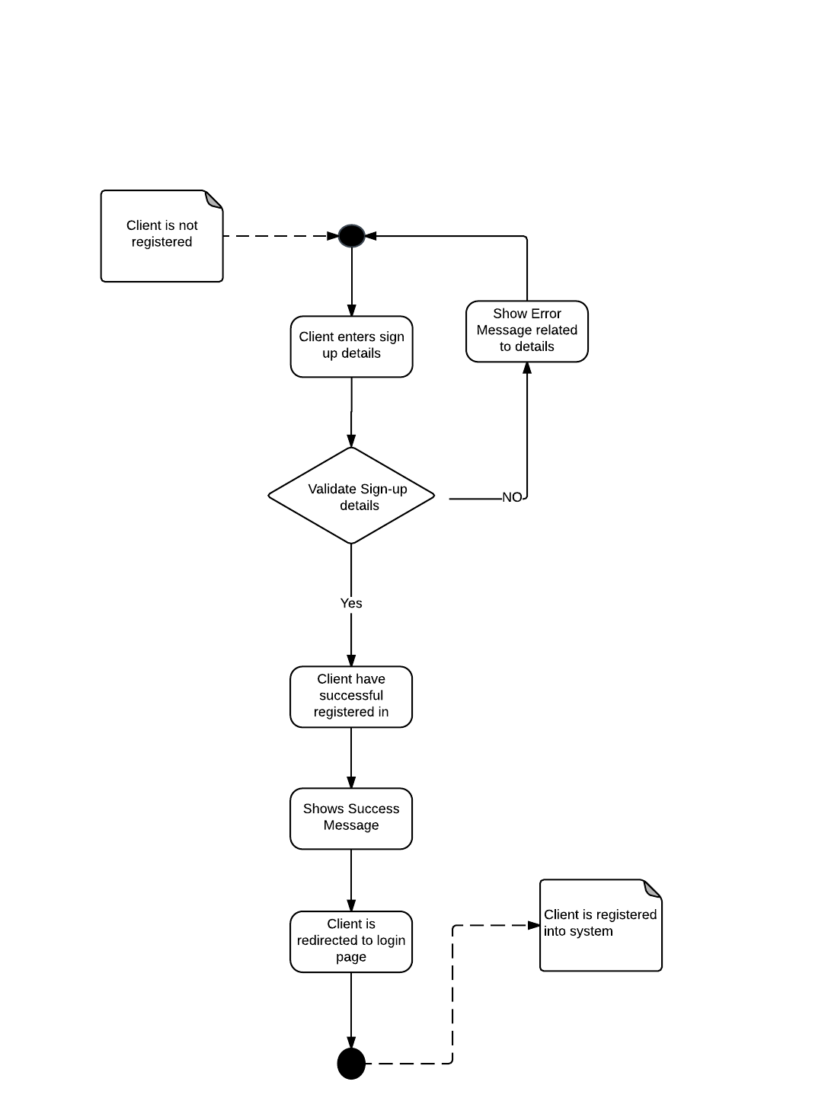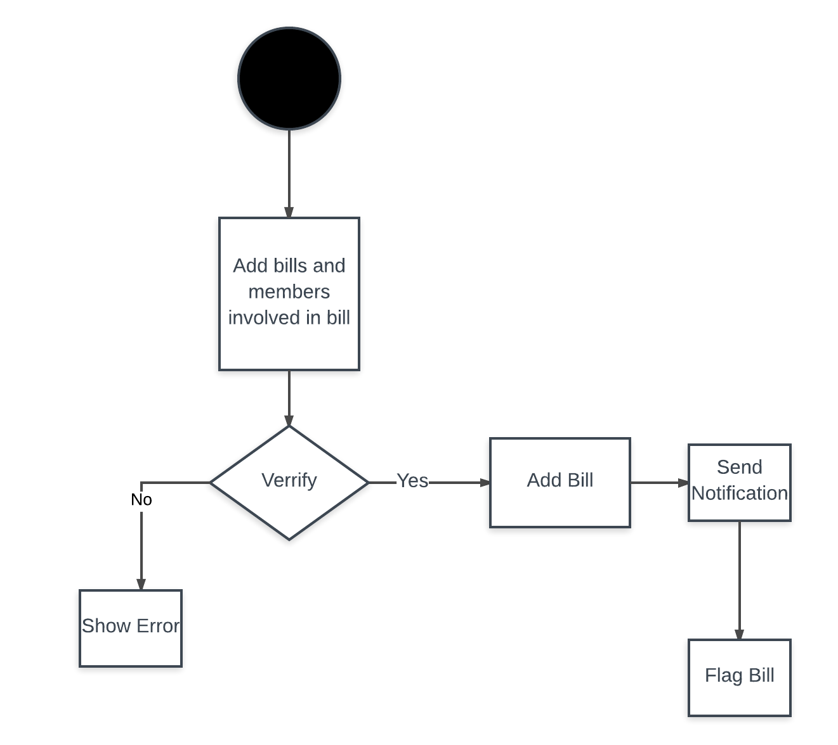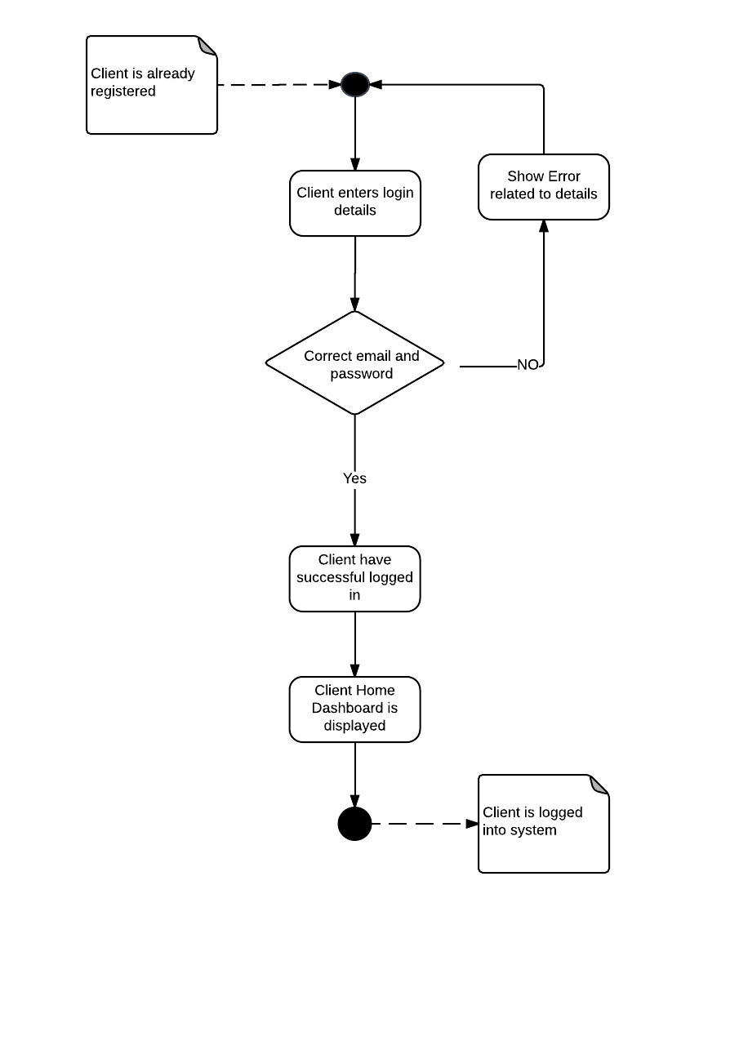

**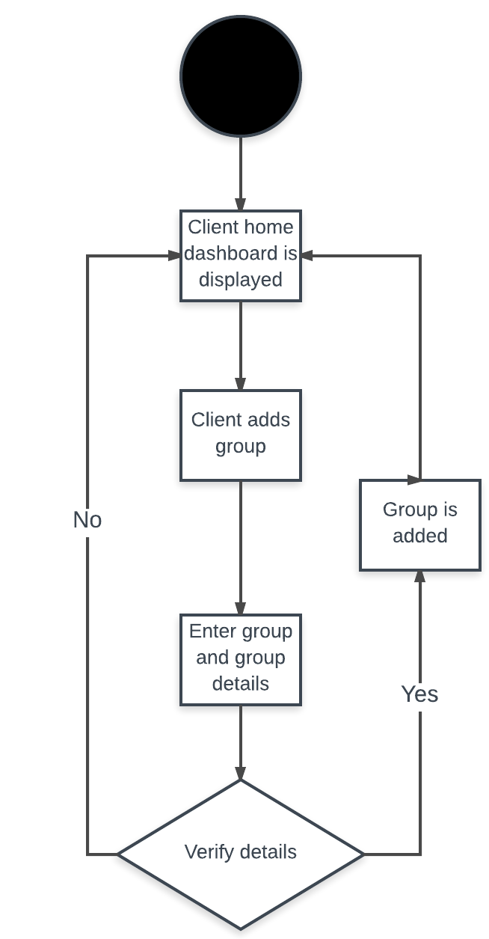**

**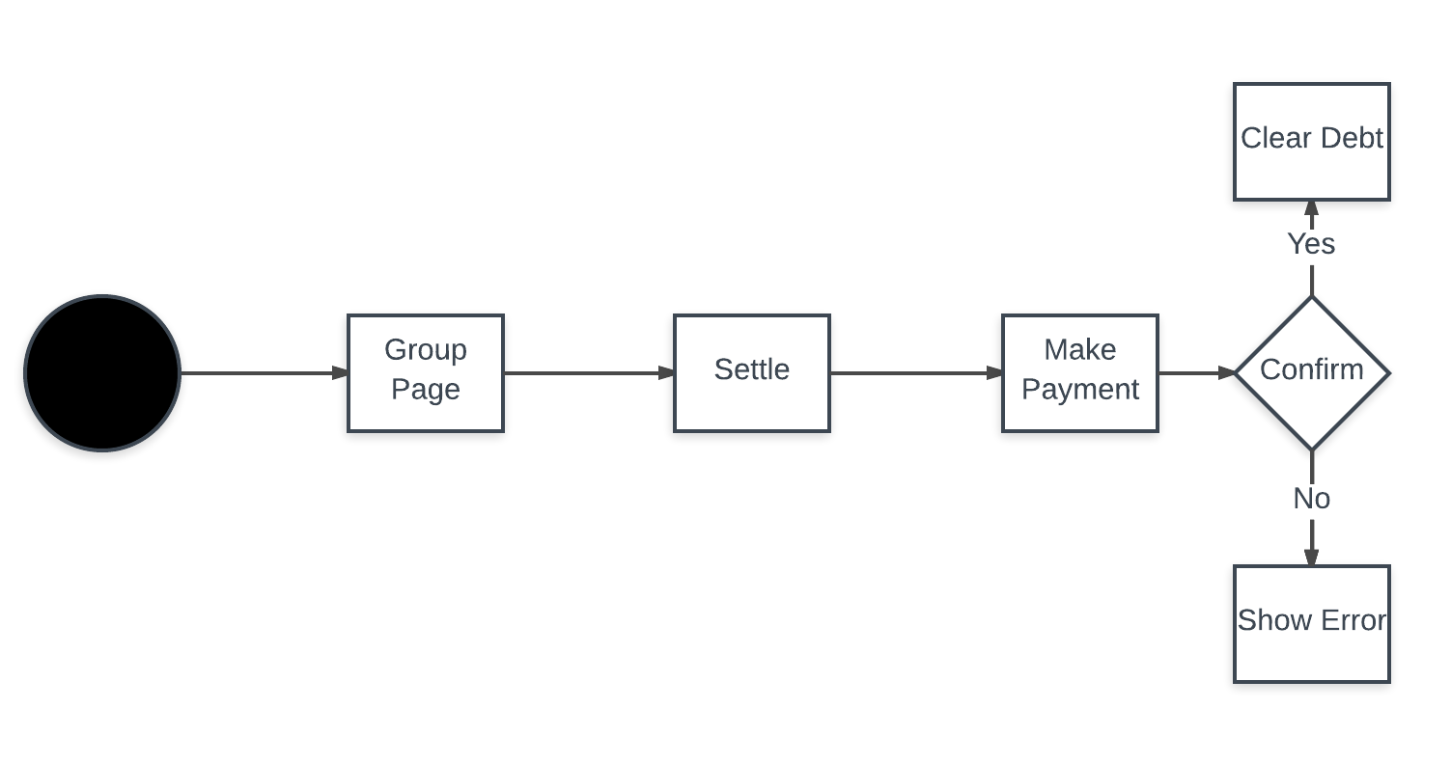**

**Section 9**

**Mindmaps for UX/UI for Persona Groups**

**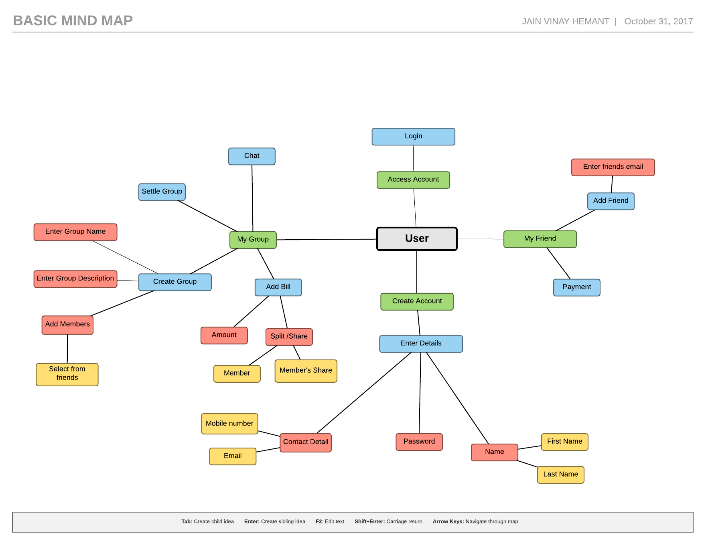**

**Section 10**

**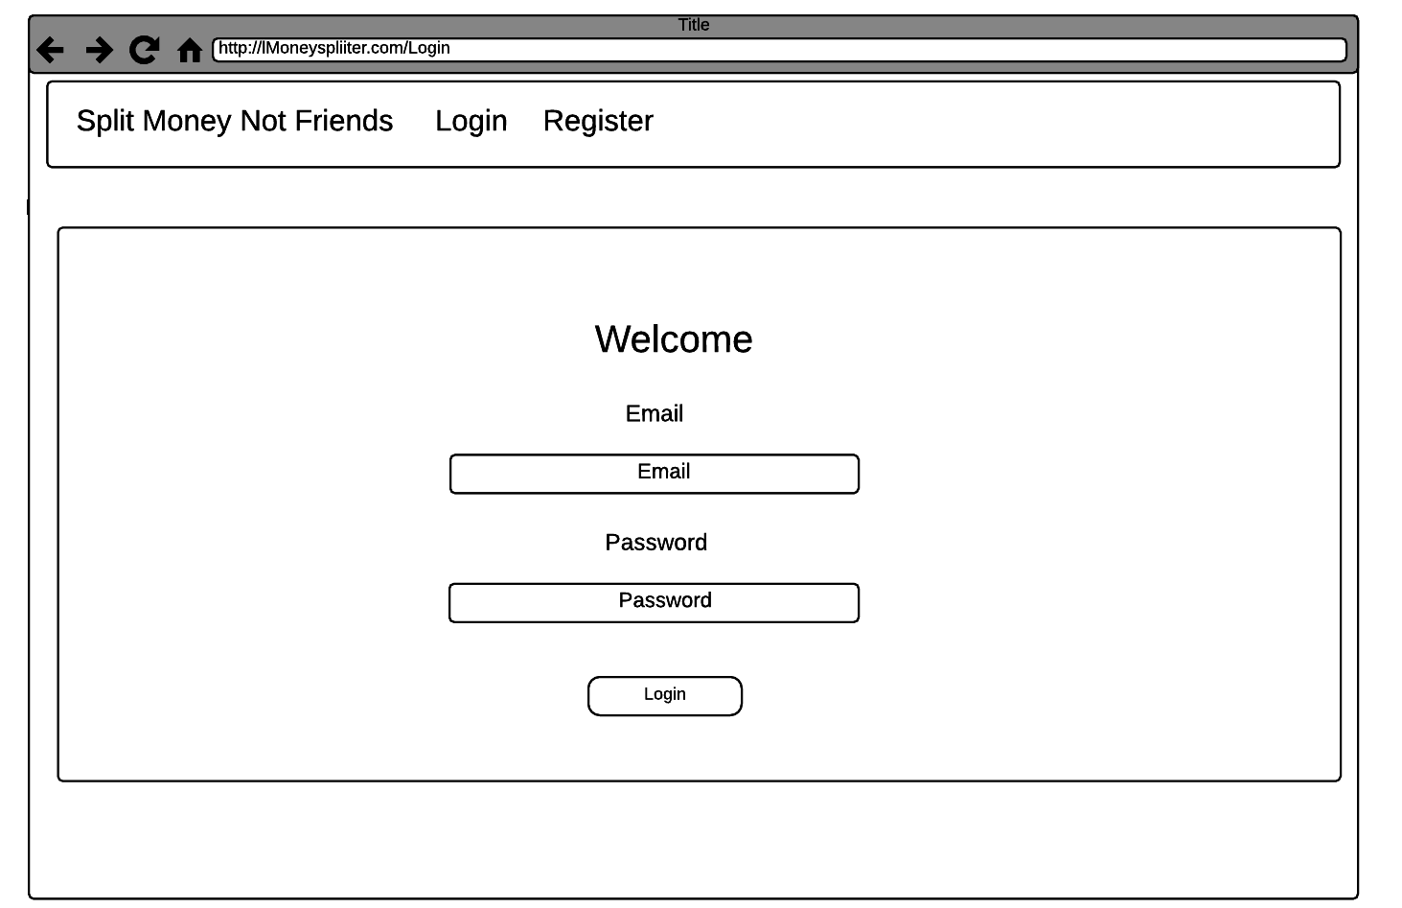UI/UX Designs (Wireframes) – For the Sprint 2 functionality**

**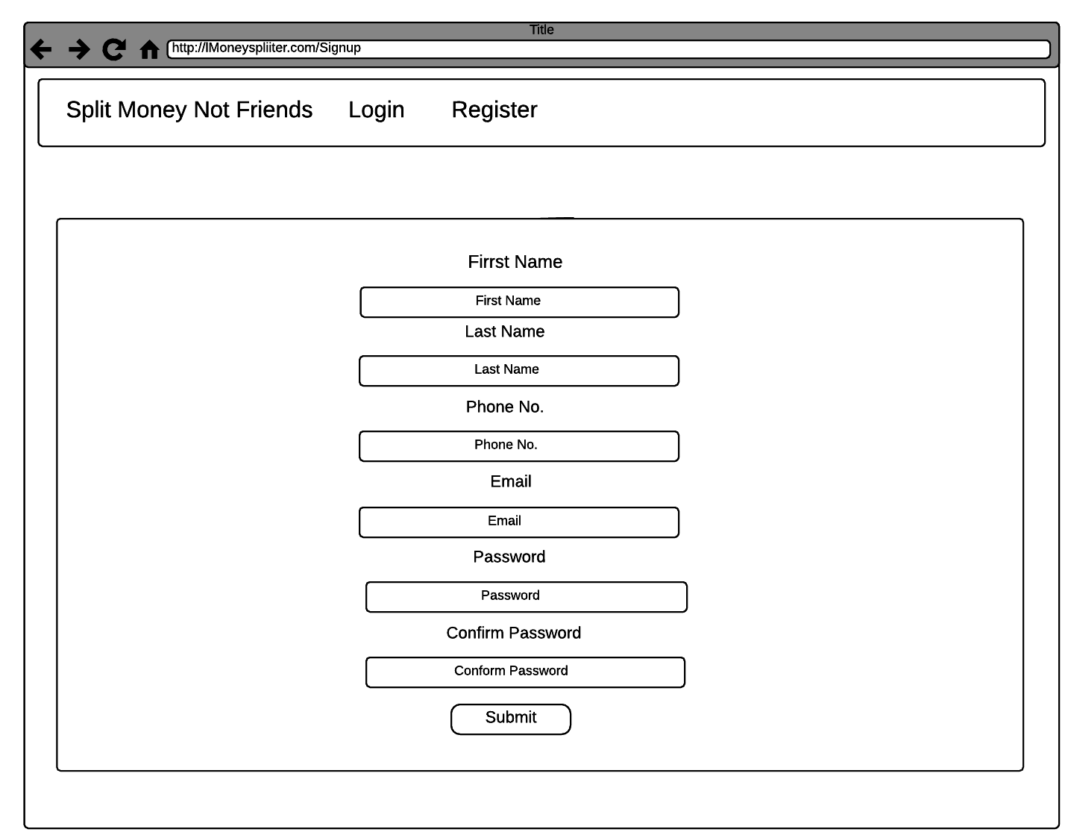**

**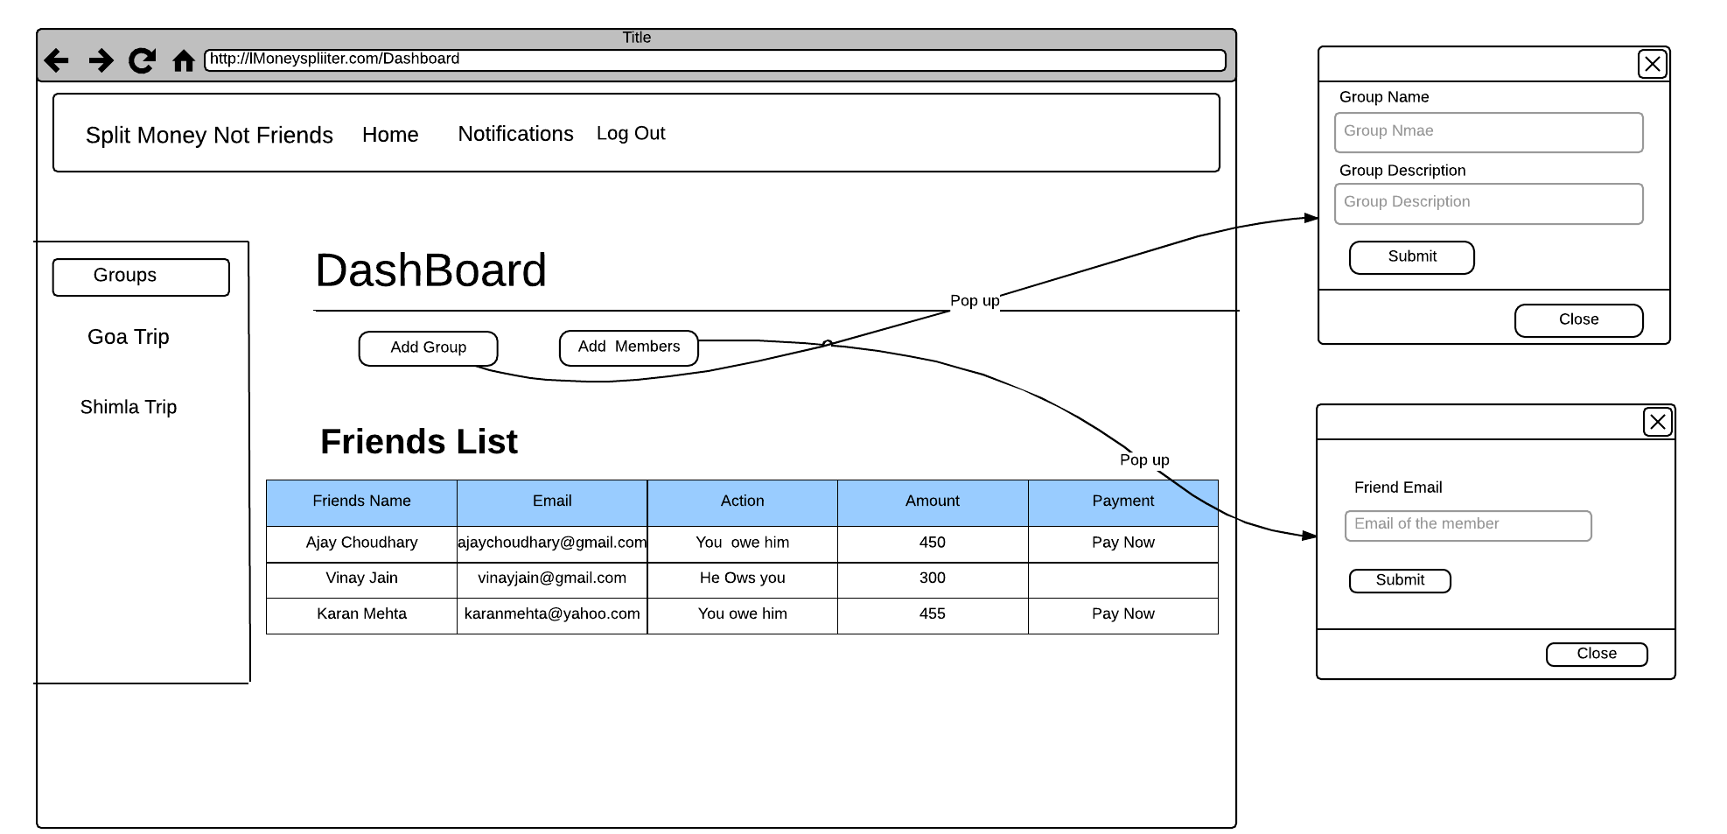**

**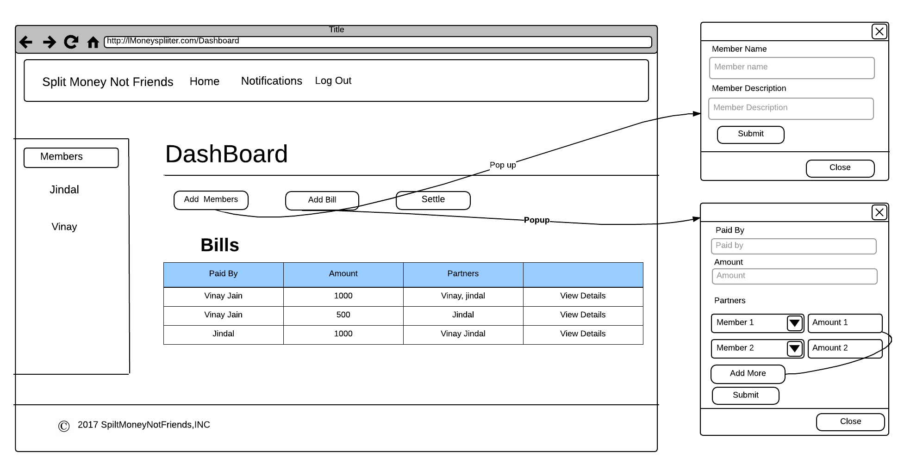**

**Section 11**

**Class diagram**

<attributes and operations should be listed on the following pages as a table>

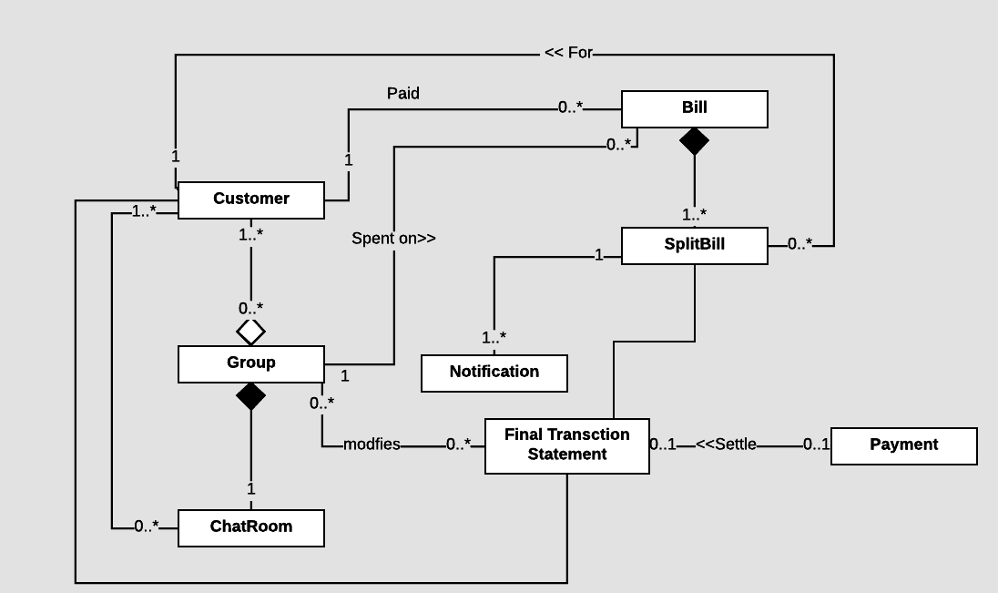

**Attributes and operations**

(show class attributes and operations with underline)

|  |  |  |
| --- | --- | --- |
| Class name | Attributes | Operations |
| Customer | User ID  First Name  Last Name  Number  Email  Password | Signup()  Login()  Logout()  CreateGroup()  AddFriend() |
| Group | Group ID  Name  Description | AddMembers()  RemoveMembers()  AddBill()  Settle() |
| ChatRoom | Messages[] | SendMessage() |
| Bill | Bill ID  PaidBy  Amount | FlagBill() |
| Split-Bill | Partner  Amount | SplitBillEqually() ,  SplitBillUnqually() |
| Notification | Message  Amount  Status | TakeAction() |
| Final Transaction Statement | To  Amount  Action | Pay() |
| Payment | From  To  Amount  Note  Status | PaymentValidate(),  AmountValidate() ,  Transacte() |

**System Architecture**

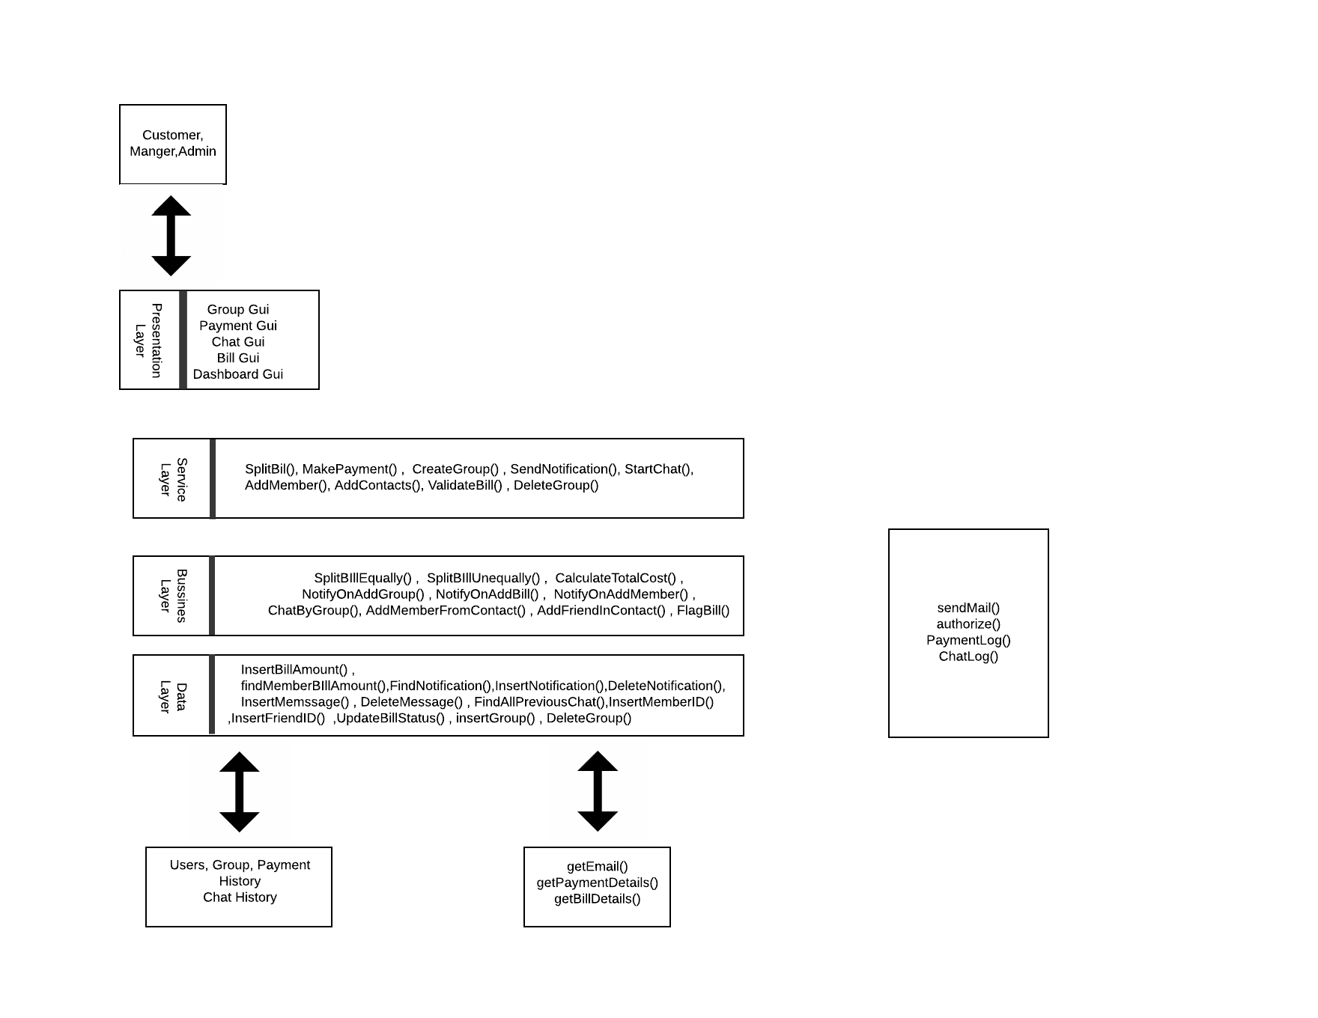**Scrum Minutes of the Meeting (Two entries per week for each team member)**

**Sprint 1 – Week 1**

|  |  |  |  |
| --- | --- | --- | --- |
| Team member | Work completed | Work planned | Impediments |
| Harshit Jindal | Learned Frontend(HTML,CSS) | Learn Frontend(HTML, CSS, Bootstrap) | Way too much material. |
| Devendra Samatia | Learned Basic Backend | Learn Backend(NodeJs) | Outdated Resources |
| Pranshu Sharma | Learned Agile Workflow | Learn Agile Workflow and project overview | Confusing material |
| Vinay Jain | Learned Basic Backend | Learn Backend(NodeJs) | Outdated Resources |
| Aayush Tibra | Learned Frontend(HTML,CSS) | Learn Frontend(HTML, CSS, Bootstrap) | Way too much material. |

**Sprint 1 – Week 1**

|  |  |  |  |
| --- | --- | --- | --- |
| Team member | Work completed | Work planned | Impediments |
| Harshit Jindal | Learned Frontend(Bootstrap,JavaScript) | Learn Frontend(Bootstrap,JavaScript) | Way too much material. |
| Devendra Samatia | Learned Backend | Learn Backend(NodeJs) | Outdated Resources |
| Pranshu Sharma | Learned NoSQL | Learn NoSQL | Outdated Resources |
| Vinay Jain | Learned Backend | Learn Backend(NodeJs) | Outdated Resources |
| Aayush Tibra | Learned Frontend(Bootstrap,JavaScript) | Learn Frontend(Bootstrap,JavaScript) | Way too much material. |

**Sprint 1 – Week 3**

|  |  |  |  |
| --- | --- | --- | --- |
| Team member | Work completed | Work planned | Impediments |
| Harshit Jindal | Nothing | Nothing | Health Issue |
| Devendra Samatia | Express Validations | Express Validations | Middleware outdating problems |
| Pranshu Sharma | Database design | Database design | Hashing Passwords |
| Vinay Jain | HandleBars,EJS | HandleBars,EJS | File connections, syntax hardness |
| Aayush Tibra | LoginPage | LoginPage | Browser incompatibility |

**Sprint 1 – Week 3**

|  |  |  |  |
| --- | --- | --- | --- |
| Team member | Work completed | Work planned | Impediments |
| Harshit Jindal | Nothing | Nothing | Health Issue |
| Devendra Samatia | Passport | Passport | Salts and database problems |
| Pranshu Sharma | Database setup | Database setup | Too less functionality in Mockaroo |
| Vinay Jain | Express, moongose | Express, moongose | Too many recent changes in API, incompatible to previous API |
| Aayush Tibra | Signup Page and Dashboard Page | Signup Page and Dashboard Page | Browser incompatibility |

**Sprint 2 – Week 1**

|  |  |  |  |
| --- | --- | --- | --- |
| Team member | Work completed | Work planned | Impediments |
| Harshit Jindal | Learn handlebars | Learn handlebars | Very small documentation |
| Devendra Samatia | Practice express other examples | Practice express other examples | Too tough |
| Pranshu Sharma | Learn Embedded MongoDB Query | Learn Embedded MongoDB Query | Nothing |
| Vinay Jain | Learn Socket.io, Nodemailer | Learn Socket.io, Nodemailer | Not well documented and few examples |
| Aayush Tibra | Learn MongoDB | Learn MongoDB | Nothing |

**Sprint 2 – Week 1**

|  |  |  |  |
| --- | --- | --- | --- |
| Team member | Work completed | Work planned | Impediments |
| Harshit Jindal | Implemented handlebars | Implemented handlebars | nothing |
| Devendra Samatia | Implemented functions | Implemented functions | Less documentation |
| Pranshu Sharma | Designed Embedded MongoDB Query | Designed Embedded MongoDB Query | Nothing |
| Vinay Jain | Practice Nodemailer and Socket.io | Practice Nodemailer and Socket.io | Too confusing |
| Aayush Tibra | Re Implement Front End from Sprint 1 | Re Implement Front End from Sprint 1 | Fixed fonts , fixed pixel values |

**Sprint 2 – Week 3**

|  |  |  |  |
| --- | --- | --- | --- |
| Team member | Work completed | Work planned | Impediments |
| Harshit Jindal | Make Dashboard and Group Page Front End | Make Dashboard Front End | Nothing |
| Devendra Samatia | Make Bill and Group Functions | Make Bill and group function | Too much interconnections |
| Pranshu Sharma | Added new databases | Added new databases | Nothing |
| Vinay Jain | Implemented chatroom | Implemented chat room | Nothing |
| Aayush Tibra | Front End Pages of payment gateway and chatroom | Front End Pages of payment gateway and chatroom | Nothing |

**Sprint 2 – Week 3**

|  |  |  |  |
| --- | --- | --- | --- |
| Team member | Work completed | Work planned | Impediments |
| Harshit Jindal | Make Dashboard and Group Page Front End | Make Dashboard and Group Page Front End | nothing |
| Devendra Samatia | Validating attributes and operation | Validating attributes and operation | Error not defined to track |
| Pranshu Sharma | New database queries and random database generated | New database queries and random database generated | Nothing |
| Vinay Jain | Implemented notification sender | Implemented notification sender | Too confusing |
| Aayush Tibra | Front End Pages of payment gateway and chatroom | Front End Pages of payment gateway and chatroom | Fixed fonts , fixed pixel values |

**Sprint 2 – Week 4**

|  |  |  |  |
| --- | --- | --- | --- |
| Team member | Work completed | Work planned | Impediments |
| Harshit Jindal | Make final changes in handlebar files and made connections | Make final changes in handlebar files and made connections | nothing |
| Devendra Samatia | Make Project report | Make Project report | Project too big to complete |
| Pranshu Sharma | Make Scrum Report | Make Scrum Report | Too much stress on group members |
| Vinay Jain | Make changes in notification sender and chatroom | Make changes in notification sender and chatroom | Too confusing |
| Aayush Tibra | Make Notification Page | Make Notification Page | nothing |

**Sprint 1 Summary**

**Review Summary (about the product)**

|  |  |
| --- | --- |
| 2 | In this sprint user will be able to create account and login into his account. |
| 1 | User is able to create group and add members to it. For now user have to add members directly through email address, as friends functionality has not been implemented. |

**Retrospective Summary (about the process)**

|  |  |
| --- | --- |
| 1 | **Benefits**  ● We learned working as a team in a coordinated manner.  ● We got to know about new technologies like NodeJs, MongoDB, Express, Passport, JavaScript, etc.  ● We got to know about new tools like Lucidchart, Xtensio, etc. |
| 2 | **Issues to be managed**  ● Crafting the first step guess was a challenge to be foreseen  ● There were few problem in synchronisation among the team members due to lack of communication, and initial planning, and voice over |
| 3 | **Lesson learned**  ● Proper time management must be implemented  ● Proper planning and deciding the workflow in the beginning of sprint is a must for any project whatsoever |

**Sprint 2 Summary**

**Review Summary (about the product)**

|  |  |
| --- | --- |
| 1 | In this sprint Customer can now add contacts from registered users of website and  Create group , also add member from contact in group. |
| 2 | User is also able to chat in a single session to discuss about debt and other issues. |
| 3 | User gets notifications on adding groups and adding member or being added in some group . |
| 4 | User can pay their bills through payment gateway. |

**Retrospective Summary (about the process)**

|  |  |
| --- | --- |
| 1 | We got to learn :   * New technologies like Bluemix, Lucidchart,mongodb,nodejs, etc. * How to work in a team and deal with different ideas . * How to sum up different ideas and bring them to a proper conclusion. |
| 2 | Problems faced:   * Initially some  members were not contributing as much as they should have. * Our work was lagging behind by few hours. * Conflict of ideas were there between members. |
| 3 | Things got well:   * All the members did their best to make the project successful. * Outcome of our web application being developed is upto our expectation. * All the team mates cooperated well with each other. * We were successful in summing up the best of our ideas. * Each member was supportive enough. |